R Studio code:

aics.freq <- transform(table(aics)) #transform internet users into a freq table

#Begin data set information#

require(graphics)

work <- diff(WWWusage)

par(mfrow = c(2, 1)); plot(WWWusage); plot(work)

## Not run:

require(stats)

aics <- matrix(, 6, 6, dimnames = list(p = 0:5, q = 0:5))

for(q in 1:5) aics[1, 1+q] <- arima(WWWusage, c(0, 1, q),

optim.control = list(maxit = 500))$aic

for(p in 1:5)

for(q in 0:5) aics[1+p, 1+q] <- arima(WWWusage, c(p, 1, q),

optim.control = list(maxit = 500))$aic

round(aics - min(aics, na.rm = TRUE), 2)

bins <- seq(5,100, by=10)

## End(Not run)

#End of data set information#

##Histogram attempt

##x=read.csv("Macintosh HD⁩ ▸ ⁨Users⁩ ▸ ⁨James⁩ ▸ ⁨Dropbox⁩ ▸ ⁨Psych 203⁩")

##attach(x)

# will not read my excel data set for some reason

Internet_usage=diff(Agrif)

summary(Internet_usage)

##########################################

hist(WWWusage)

hist(WWWusage, breaks = 50, xlim = c(0,250),

xlab = "Internet Users", ylab = "Frequency", main = "Histogram of Internet Usage per Minute")

Histogram:

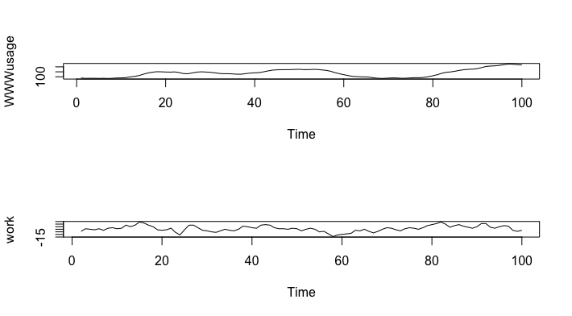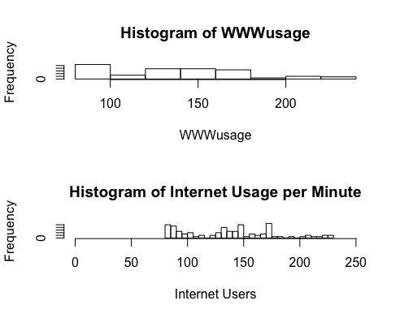

Environment:

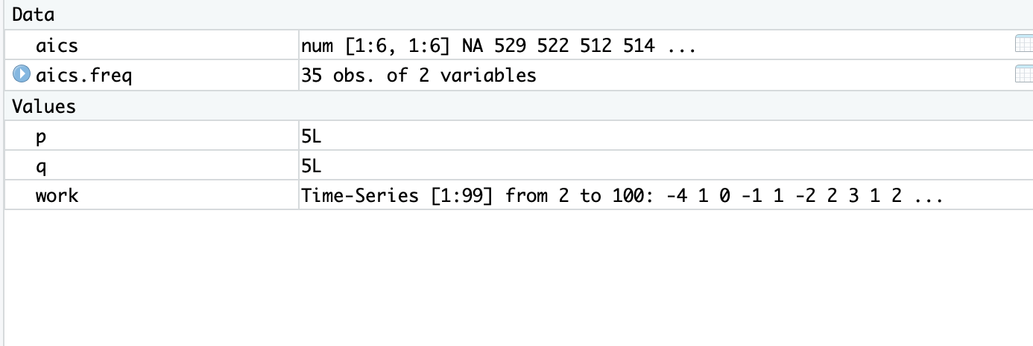

Frequency Grouped and ungrouped:

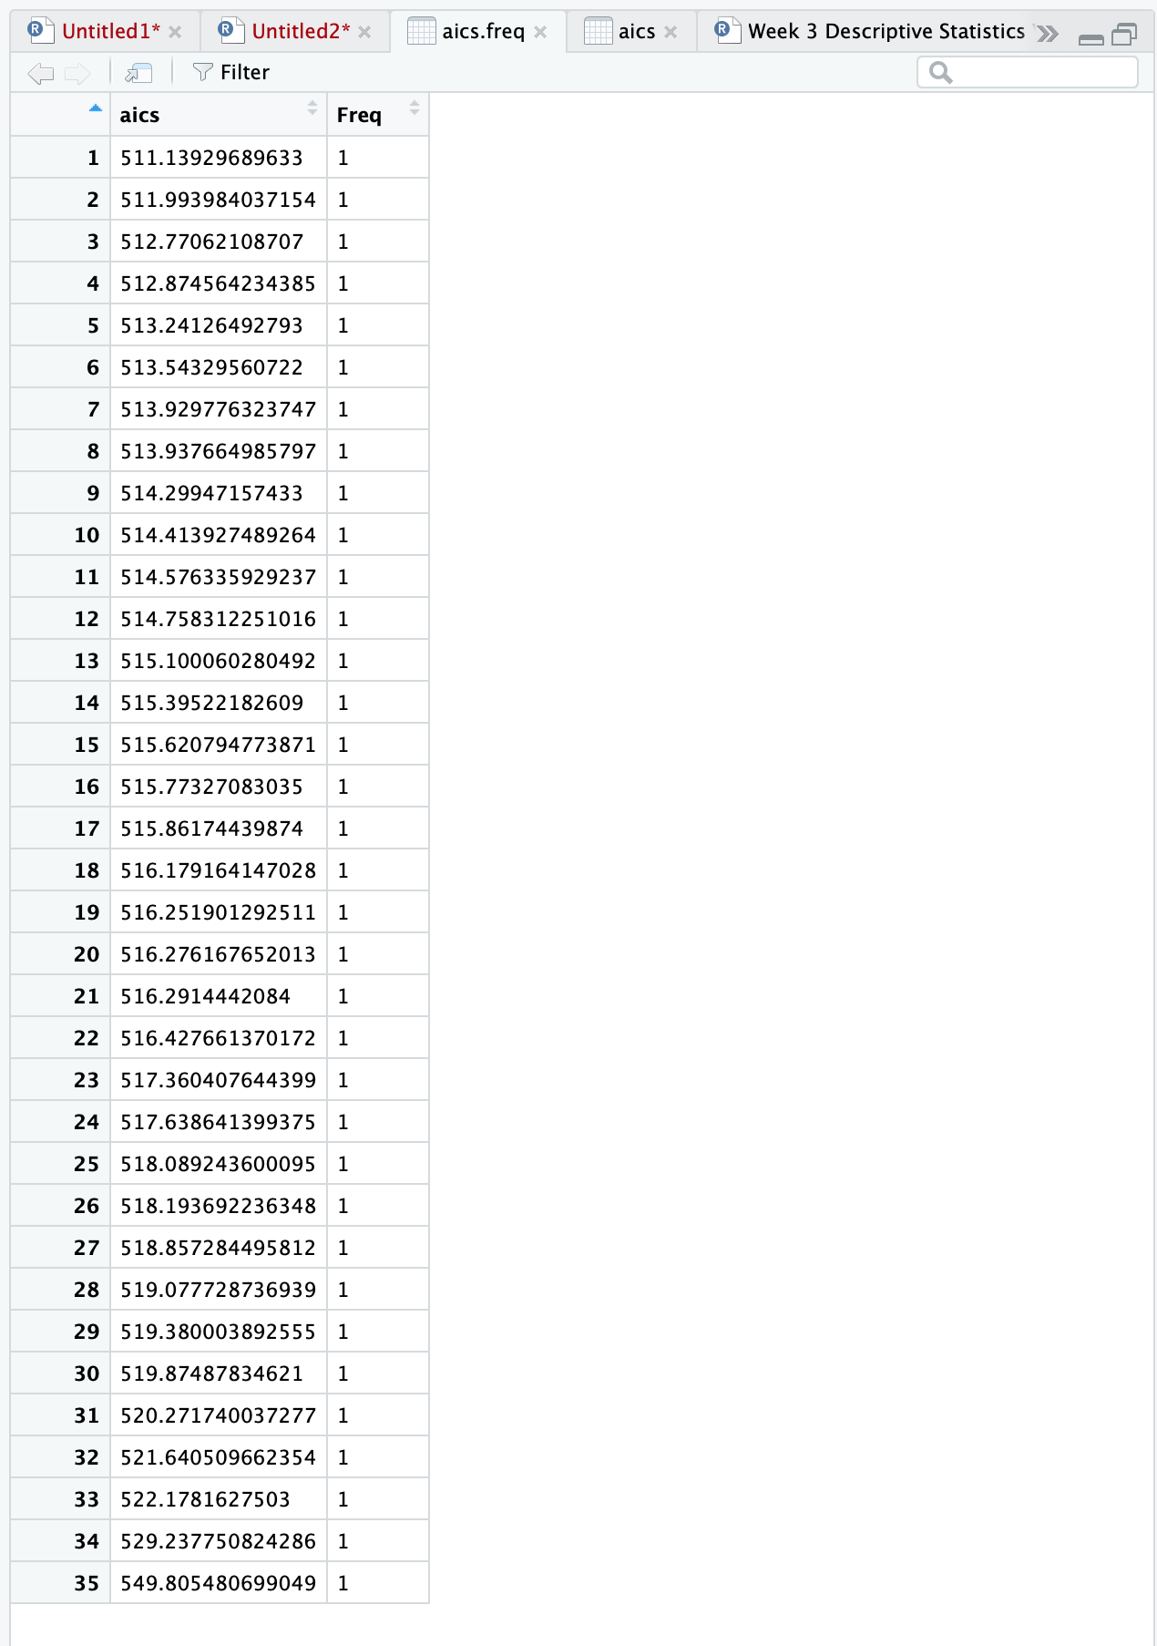

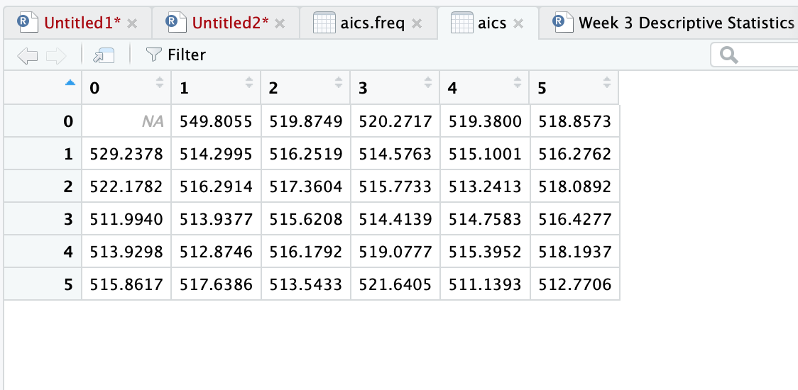

Console:

